Threat Analysis
We’ll identify 2 key threats using STRIDE, then draw an attack tree for one of them.

🎯 STRIDE Threats (Specific to API Token Security + Flask Wrapper)
STRIDE Category | Threat | Description | Impact
S – Spoofing | Client impersonation via stolen API token | An attacker steals or guesses a client’s Bearer token and makes unauthorized requests. | Unauthorized access, quota abuse.
T – Tampering | Modification of OpenAI API response in transit | MITM attack injects or alters chatbot responses before reaching the user (if HTTPS is misconfigured). | Misleading or manipulated AI replies.
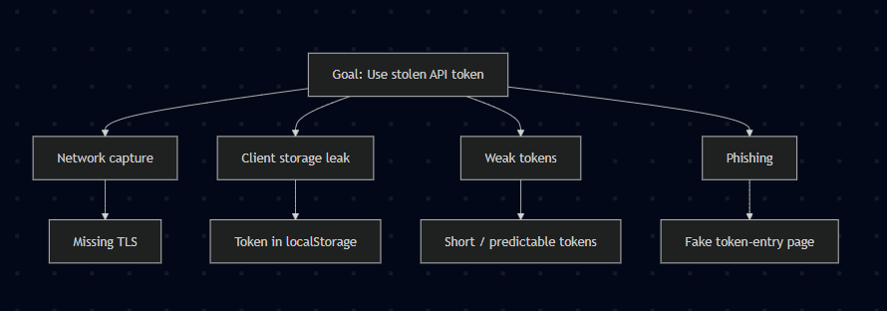

Explanation (for each node)
Goal: Use stolen API token
An attacker’s objective is to obtain a valid client bearer token and call the chatbot API as that client, gaining unauthorized access and possibly abusing quotas or data.
Network capture (Missing TLS)
If traffic between the client and API is not fully encrypted (no HTTPS, mixed content, or weak TLS), an attacker on the same network or in-path can sniff or tamper with requests and extract bearer tokens.
Client storage leak (Token in localStorage)
When client apps store tokens in insecure places (e.g., browser localStorage, plain config files, or unprotected device storage), a local attacker or malicious script can read and exfiltrate the token.
Weak tokens (Short / predictable tokens)
Tokens with low entropy, predictable patterns, or long lifetimes can be guessed or brute-forced—especially when authentication endpoints lack rate-limiting—allowing attackers to discover valid tokens.
Phishing (Fake token-entry page)
Users or admins can be tricked into pasting their token into a malicious page or form, or into entering credentials that reveal tokens, which the attacker then reuses against the API.

Mitigations (mapped to nodes and prioritized)

Immediate (high priority)
- Enforce TLS + HSTS (mitigates Network capture)
  - Require HTTPS on all endpoints, redirect HTTP → HTTPS, enable HSTS, and disable old TLS versions.
  - Use strong cipher suites and regularly scan for TLS misconfigurations.
- Avoid localStorage; use secure storage + short-lived tokens (mitigates Client storage leak)
  - For web clients, prefer httpOnly, secure cookies with sameSite where applicable, or a backend session proxy.
  - For native apps, use platform secure storage (iOS Keychain / Android Keystore).
  - Design tokens to be short-lived (minutes) and use refresh tokens held in secure storage.
- Use strong, high-entropy tokens + scopes (mitigates Weak tokens)
  - Generate tokens with sufficient entropy (≥128 bits) or use signed JWTs with short expiry and minimal scopes.
  - Avoid predictable token formats.
- Rate-limit & anomaly detection (mitigates Weak tokens & general abuse)
  - Apply per-client throttling, exponential backoff on auth failures, and detect unusual usage patterns (sudden spike, geo-drift).
  - Block or temporarily suspend suspicious clients automatically.

